IT24102522

Himandi A H S

Lab 05

Exercise

01)

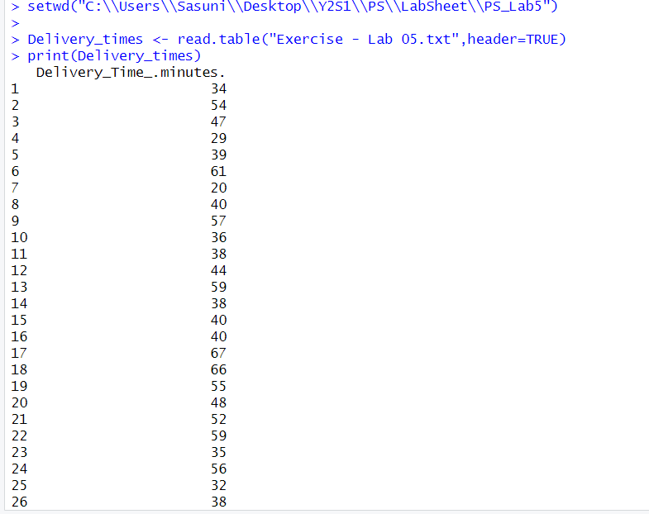

02)



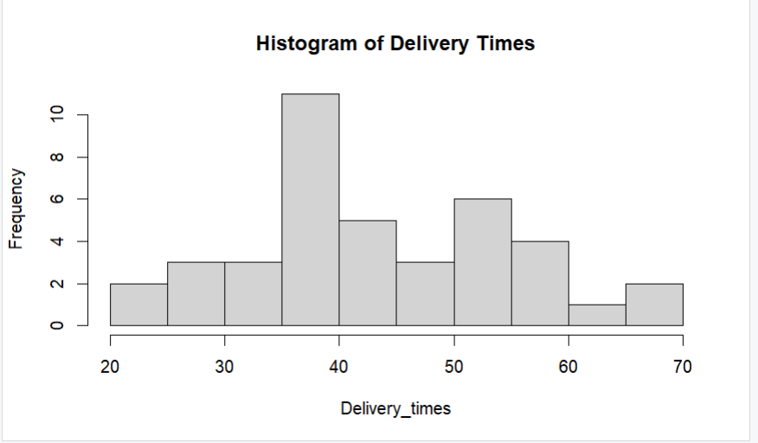

03)

The distribution of delivery times is approximately symmetric and unimodel, with the peak around 35-40 minutes. It is not strogly skewed.

04)

